Lab #9
Programming and Algorithms

Please complete all of the following questions:

- Write a program to calculate the average of the following multi-dimensional array:
# PROGRAM ArrayAverage:
MArray = [[2,4,7],[3,6,3]]
<DO STUFF>
print(Average)
# END.

- The Main Diagonal of a matrix is as follows:

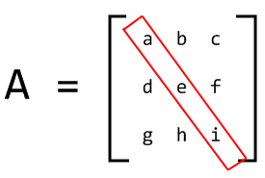
Print the Main Diagonal of the following array:
[[2,4,7],[3,6,3],[8,4,6]]

e-mail me a completed solution to each of the above programs in a Word document, and include Labs #1-#8 in this document also.
e-mail to Damian.Gordon@dit.ie with subject heading “DT255 PaA Lab #1-9”

