Lab #8
Programming and Algorithms

Please complete all of the following questions:

- Given the following code to sort integer number:
# PROGRAM Bubblesort:
Age = [44, 23, 42, 33, 18, 54, 34, 16]
for outerindex in range(0,len(Age)):
# DO
for index in range(0,len(Age)-1):
# DO
if Age[index+1] < Age[index]:
# THEN
TempValue = Age[index+1]
Age[index+1] = Age[index]
Age[index] = TempValue
# ENDIF;
# ENDFOR;
# ENDFOR;
print(Age)
# END.
Change the code so that it sorts the following arrays
[34.23, 12.34, 545.43, 64.32, 11.11, 36.74]
[‘b’, ‘d’, ‘a’ ,’f’, ’u’, ‘r’,’R’,’2’,’@’]
[“Hello”, “Goodbye”, “How are you?”, “File not found 404”]
[False, True, True, True, False, True, True]

- The Confidence Interval is calculated as follows:

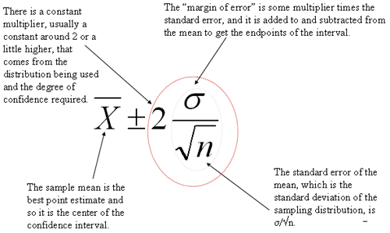

Given the following array:
[44, 23, 42, 33, 18, 54, 34, 16]

Write a Python program to print out two values:

- The Average of the values in the array, minus two times the Standard Deviation, divided by the square root of 8.
- The Average of the values in the array, plus two times the Standard Deviation, divided by the square root of 8.

e-mail me a completed solution to each of the above programs in a Word document, and include Labs #1-#7 in this document also.
e-mail to Damian.Gordon@dit.ie with subject heading “DT255 PaA Lab #1-8”

