MSc in Computing (Knowledge Management)

Dissertation Proposal Form

The form, fully completed, must be returned to:

Brendan Tierney
School of Computing
Dublin Institute of Technology
Kevin Street
Dublin 8.

Or by e-mail to: brendan.tierney@dit.ie

For Office Use Only

Recommendation: Project Number:

Supervisor: Second Reader:

TITLE OF PROJECT | Investigation of the visualisation aspects of business intelligence
STUDENT NAME:
STUDENT NUMBER:
NAME OF SCHOOL/DEPT: | Computing
CONTACT TELEPHONE NO:
CONTACT MOBILE NO:
DIT EMAIL ADDRESS:
OTHER EMAIL ADDRESS:
CONTACT ADDRESS:
HOME ADDRESS:
SUMMARY OF PROJECT (not to exceed 350 words):

The dissertation looks at different techniques for visualisation of knowledge in business intelligence. It aims at comparing how effective these techniques are by evaluating the visualisation capabilities of several different DM tools on the same datasets.
The hypothesis is that specific business intelligence tools are more effective than others depending on the type of dataset, these tools will include WEKA open source data mining tools, SAS tools and Oracle data miner and discover. Measurements will be drawn to see how successful in representing knowledge based on usability and how easy it is to understand the results.

OTHER INSTITUTIONS / DEPARTMENTS / PERSONNEL ASSOCIATED WITH THE PROJECT:
Student:
Supervisor
Organisation
Case Study Contacts

FULL DESCRIPTION OF PROJECT:
Please specify objectives, work programme (including target dates); evaluation criteria and benefits likely to accrue from the successful completion of the project. Please use additional pages if necessary.
Project Background

Forecasts for 2008 predict that a US recession may be fast approaching. This has forced even more large organisations to rethink there business plans in order to stay ahead in a highly competitive global environment. The focus is on efficiency, innovation and using the knowledge within there organisation effectively in a timely manner.
Those who are managing there knowledge well have a serious advantage over competitors which is why business intelligence will be come increasing important. The big players of Oracle, SAP, IBM have already realised this fact with all three acquisitions to there business intelligence portfolios within the last year buying up Hyperion Software, Business Objects and Cognos respectively [Stoder, 2008]. Each hoping these CEO data mining reporting tools will give them the best package solution.
One of the exciting areas of innovation at the moment in this area is the visualisation tools, as both academics and organisations aim at making knowledge representation more effective. The reason behind it is that even in those companies who use business intelligence extensively, decision makers still say in surveys that it only influences them 28 percent of the time in making decisions. One of the reasons for this is often it is difficult to interpret the results of data mining, however using visualisations has proven to be very successful in this regard. This paper will look at some of the techniques used to visualise this knowledge, look at its effectiveness and how different tools approach visualisation of knowledge.

Project Description

Several papers in real time systems from Di Yang and Elke Rundensteiner will be used as a background to the project. They deliver interesting concepts on visualisation techniques to make data mining results more comprehensible and look at problems of visualising and analysing large dataset results.
The aim is to show how the visual techniques are applied by different business intelligence tools and how effectively do they represent the knowledge. The datasets used for the analysis will be from three different KDD cup datasets which will provide good coverage of the tools effectiveness over different areas. There will be challenges in become familiar with the tools, and finding effective measures for comparing there most successful.
It is assumed that a small amount of development may be needed for a measurement tool, inserting data into the dataset. However the intention is to keep the development time under 3 weeks, to prevent it affecting other areas. .
The intention is to test with range of tools for the experiment, to give a well rounded view of implementing the solution and reducing the bias of using different tools. Among the tools which will be looked at using will be the Weka open source data mining tool, Oracle data miner and discoverer, SAS tools and other data mining tools. The choice and use of these tools will depend on availability and time constraints to work on the tools.
The effectiveness of the tools will be measured using the technique and usability measurements. Again the measurements will be affected by the type of dataset being used as some tools may display data more effective than others..

Project Aim

The aim is critical analyse the techniques used for visualisation in business intelligence on different types of data, to identify the benefits and drawbacks of each and practically examine how effective different tools available are at mapping knowledge.

Project Objectives

- Establish the work done on the area to date
- Apply the theories to the results from several datasets
- Measure the success of each system
- Reflect on the process, identify future work and conclusions

Evaluation Criteria

- The application success of the proposed theories by comparing business intelligence tools such as commercial and open source data mining tools.
- The ease of understanding the results and the quality of the results returned
- Usability of the business information produced.

Deliverables

- Literature Review
- Testing and output from the systems
- Dissertation
- Analysis and findings material

Timeframes & Project Plan
Include key timeframe, milestones, grant chart, identify risk and an RMMM matrix (Risk, Measurement, Monitor, Mitigation)

Milestone | Timeframe/Dates
Background research | November – January 2008
Submission of project proposal | 18th January 2008
Start research and dissertation | 11th January 2008
Presentation of project proposal | 6th February 2008
Allocation of supervisor | 4/11th February 2008
Research and meeting with supervisor | February to April, 2008
Submission of first draft of dissertation | 2 April, 2008
Submission of dissertation for examination | Tuesday 6th May, 2008
Presentation/Examination of dissertation | Approx. first week in June
Submission of hard bound dissertation | Mid May, 2008
External examiner, progression board meeting | Mid June, 2008

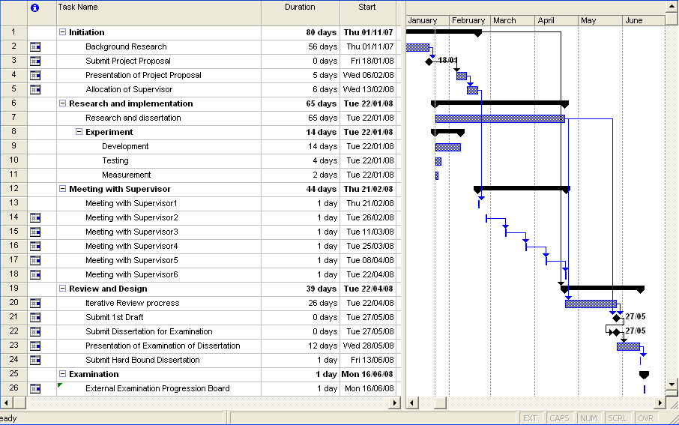

Technical and Non-Technical Resources Required

Human Resources:
- Access to supervisor
- Possible access to subject experts for views on area

Technical:
- Access to Oracle Data miner and Discoverer
- Access to SAS Data Miner
- Access to Weka
- Personal laptop

References

[Stodder, 2008]
Title: BI Megatrends 2008
URL:http://www.intelligententerprise.com/channels/business_intelligence/showArticle.jhtml?articleID=205602945&pgno=5
Accessed: 11 December 2008
Author: David Stodder

[Nguyen, 2006]
Title: Zero-Latency Data Warehousing (ZLDWH): the State-of-the-art and experimental implementation approaches
Author: Tho Manh Nguyen, and A Min Tjoa
Published: IEEE Volume, Issue, Feb. 12-16, 2006 Page(s): 167 - 176

[Seufert, 2005]
Title: Enhanced Business Intelligence - Supporting Business Processes with Real-Time Business Analytics
Author: Andreas Seufert and Josef Schiefer, University of Applied Science Ludwigshafen
Published: IEEE Volume, Issue, 22-26 Aug. 2005 Page(s): 919 – 925

[Sefanov,2005]
Title: Bridging the Gap between Data Warehouses and Organizations
Author: Veronika Stefanov
Published : IEEE Computer Society 2005, Pages: 3 - 14

[Erkekin,2007]
Title: Learning on the Border: Active Learning in Imbalanced Data Classification
Authors: Seyda Ertekin, Jian Huang, L´eon Bottou, C. Lee Giles
Published: ACM New York, NY, USA 2007, Pages: 127-136

[Don,2007]
Title: Discovering interesting usage patterns in text collections: Integrating text mining with visualization
Author : Anthony Don
Published: ACM New York, NY, USA 2007, Pages 213-222

[Yang,2007]
Title: Nugget Discovery in Visual Exploration Environments by Query Consolidation
Authors : Di Yang, Elke A. Rundensteiner, Matthew O. Ward
Published: ACM New York, NY, USA 2007, Pages 603-612

[Yang2,2007]
Managing Discoveries in The Visual Analytics Process
Di Yang, Zaixian Xie, Elke A. Rundensteiner and Matthew O. Ward
Published: KDD 07 conference paper 2007, Volume 9, Issue 2

[Rundensteiner ,2007]
Title: XmdvToolQ: Quality-Aware Interactive Data Exploration
Authors: Elke Rundensteiner , Matthew Ward, Zaixian Xie, Qingguang Cui, Charudatta Wad, Di Yang, Shiping Huang
Published: International Conference on Management of Data – SIGMOD, 2007

Signed : _________________________________ Date : _____________________

