A Review of the Use of Technique in Creativity and Problem Solving
Damian Gordon, D12345678, Damian.Gordon@dit.ie
Abstract—This paper looks at the use of technique in the Problem Solving domain, It first introduces technique; how it works and how to use it. Following that two papers are reviewed that use this techniques. The first paper, Authors (YEAR), looks at the use of this technique in the context of CONTEXT. The second paper, Authors (YEAR), looks at another use of this technique in the context of CONTEXT. Following these papers an experiment undertaken by the author is detailed, explain the context in which it was uses, how it was used, what results were achieved, and some reflections on the process.

Index Terms— Problem Solving, Creativity, Technique, Innovation.

INTRODUCTION
T
HIS paper looks at the technique creativity technique, which was developed by Someone in 19XX. It was developed to address a particular need. It works as follows:
- You do this
- Then you do this
- Then this
- And this

This technique is particularly useful for SOMETHING.

Other Researchers Use of Technique
In this section we’ll review two papers who have used technique in their work, and look at how they have used it and the outcomes of its use. The two papers we are going to look at are “Title” by Authors in 20XX, and “Title” by Authors in 20XX.

First Paper

The first paper, Authors (YEAR), looks at the use of this technique in the context of CONTEXT.

Their approach was to ..

Their outcomes were …

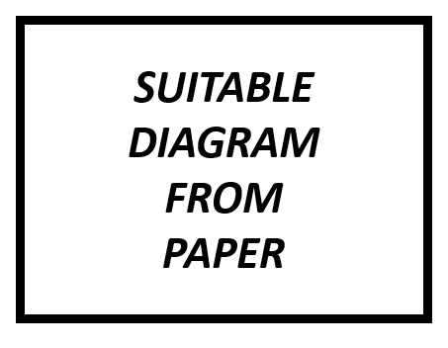
Fig. 1. Suitable Diagram from First Paper

Second Paper

The second paper, Authors (YEAR), looks at another use of this technique in the context of CONTEXT.

Their approach was to ..

Their outcomes were …

Fig. 2. Suitable Diagram from Second Paper

My Experiment
If you are using Word, use either the Microsoft Equation Editor or the MathType add-on (http://www.mathtype.com) for equations in your paper (Insert | Object | Create New | Microsoft Equation or MathType Equation). “Float over text” should not be selected.

Fig. 3. Suitable Diagram from me!

Reflections

The goal of this paper was to reflect on the use of technique, and to explore scenarios where it can be used effectively. To this end technique was first explained, then two papers that use it were discussed, as well as my own experiment using this techniques.
My key reflections on this technique are as follows:
- Aaaaaaaaaaaaaaaaaaaaaaaaaaaaaaaaaaaaaaaaaaaaaaaaaaaaaaaaaaaaaaaaaaaaaaaaaaa
- Bbbbbbbbbbbbbbbbbbbbbbbbbbbbbbbbbbbbbbbbbbbbbbbbbbbbbbbbbbbbbbbbbbbbb
- Ccccccccccccccccccccccccccccccccccccccccccccccccccccccccccccccccccccccccccccc
- Ddddddddddddddddddddddddddddddddddddddddddddddddddddddddddddddddddddddddddddddddddddddddddddddddddddddddddddddddd
- Eeeeeeeeeeeeeeeeeeeeeeeeeeeeeeeeeeeeeeeeeeeeeeeeeeeeeeeeeeeeeeeeeeeeeeeeee

References

- Sternberg, R. J. (1999) “Handbook of Creativity”, Cambridge University Press.
- Mihaly, C. (2013) “Creativity: The Psychology of Discovery and Invention” Harperperennial: New York.

