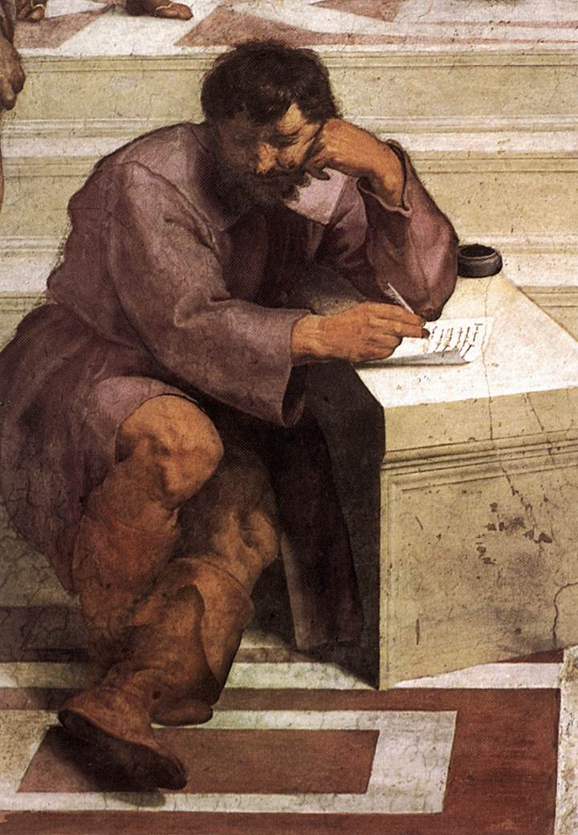

Heraclitus

Damian Gordon
Student #: D12345678
DTXXX: MSc in Computing (Stuff)

Heraclitus

Heraclitus of Ephesus (535BC–475BC) was a philosopher and also a mystery. He is said to have written a treatise On Nature, in three parts, one on the universe, another on politics, and a third on theology, unfortunately only a little of it survives. And the little that does survive are quotes from this work in the works of other later authors. Some of these quotes (or fragments) make perfect sense by themselves (e.g. "You cannot step twice into the same river") whereas others are unclear without the context around them (e.g. "all things come to be in accordance with this Logos"). For me the ideas of Heraclitus - about change, about ebb-and-flow, and about the nature of life - are really cool and strike a chord with me. Also a favourite hobby of mine is taking all the fragments and trying to group them into themes, and arranging them sensibly into specific parts of the three sections of Heraclitus' treatise. Of course it's not only me who does this, over the centuries it has become a favourite hobby of many philosophers, including (perhaps most famously) Martin Heidegger.

References

Websites:

Wikipedia Page
http://en.wikipedia.org/wiki/Heraclitus

The Flux and Fire Philosophy of Heraclitus
http://www.thebigview.com/greeks/heraclitus.html

Heraclitus Quotes
http://www.quotationspage.com/quotes/Heraclitus/

The Fragments of Heraclitus
http://www.heraclitusfragments.com/

Damian Gordon's Page on the Pre-Socratic Philosophers
http://www.comp.dit.ie/dgordon/Lectures/Hum1/030926/030926hum.htm

Books:

Barnes, Jonathan. Early Greek Philosophy. Penguin Books, 1987.
Barnes, Jonathan. The Presocratic Philosophers. Routledge, 1982.
Burnet, John. Early Greek Philosophy. London, 1920.
Diels, Hermann. Die Fragmente der Vorsokratiker. ed. Walther Kranz. Berlin, 1951.
Guthrie, W.K.C. History of Greek Philosophy. 2 Vols. Cambridge UP, 1962.
Heidegger, Martin; Fink, Eugen; Seibert (translator), Charles H. (1993). Heraclitus Seminar. Evanston: Northwestern University Press.
Johnstone, Henry W., Jr. Heraclitus' Perì Phûseos. Bryn Mawr Commentaries, 1984.
Kahn, Charles. Anaximander and the Origins of Greek Cosmology. Hackett Publishing, 1994.
Kahn, Charles. The Art and Thought of Heraclitus. Cambridge UP, 1979.
Kirk, G.S., J.E. Raven & M. Schofield. The Presocratic Philosophers. 2nd edition. Cambridge UP, 1983.
Marcovich, M. Heraclitus, editio maior. Merida, Venezuela, 1967.
Mourelatos, A.P.D. The Pre-Socratics. Princeton UP, 1974.
Robinson, T. M. Heraclitus: Fragments. U Toronto P, 1987.

Papers:

Fränkel , H., 1938, "A thought pattern in Heraclitus", American Journal of Philology.
Vlastos, G., 1955, "On Heraclitus", American Journal of Philology.

Timeline for Heraclitus

535BC | Heraclitus is born in Ephesus, present-day Efes, Turkey to an aristocratic family. His father may have that he abdicated the kingship in favour of his brother.
~ 530-520BC | Heraclitus was "wondrous" student from childhood. As a boy Heraclitus had said he "knew nothing" but later claimed to "know everything."
~ 475BC | Heraclitus dies aged 60 years old; his cause of death may have been dropsy. He treated himself for it with a liniment of cow. After a day of treatment he died and was interred in the marketplace.
1510 | Raphael paints "The School at Athens" wherein he represents Heraclitus with his head leaning on one arm, while writing with the other.
1630 | Johannes Moreelse paint the famous "Weeping Philosopher" image of Heraclitus, a title given to him based on the suggestion that he didn't finish some of his works because of melancholia.
1970 | Existential philosopher Martin Heidegger publishes his opus on Heraclitus ("Heraclit" in German) which is translated into English in 1993 by Eugene Fink.

