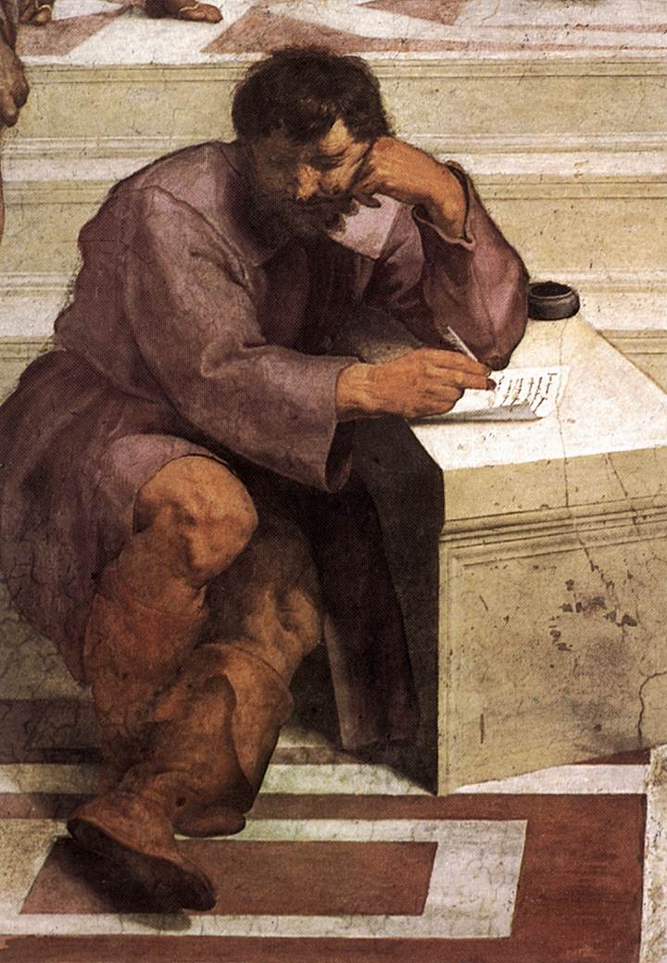

Heraclitus

Damian Gordon
Student #: D12345678
DTXXX: MSc in Computing (Stuff)

Heraclitus

Heraclitus of Ephesus (535BC–475BC) was a philosopher and also a mystery. He is said to have written a treatise On Nature, in three parts, one on the universe, another on politics, and a third on theology, unfortunately only a little of it survives. And the little that does survive are quotes from this work in the works of other later authors. Some of these quotes (or fragments) make perfect sense by themselves (e.g. "You cannot step twice into the same river") whereas others are unclear without the context around them (e.g. "all things come to be in accordance with this Logos"). For me the ideas of Heraclitus - about change, about ebb-and-flow, and about the nature of life - are really cool and strike a chord with me. Also a favourite hobby of mine is taking all the fragments and trying to group them into themes, and arranging them sensibly into specific parts of the three sections of Heraclitus' treatise. Of course it's not only me who does this, over the centuries it has become a favourite hobby of many philosophers, including (perhaps most famously) Martin Heidegger.

