Reigeluth’s Elaboration Theory
A task sheet for students to work through several times and hopefully then internalise.

 | Activity | Example | Why?
1 | Organizing Course Structure |  | Begin the course with a concrete example that epitomizes the key ideas of module
2 | Within-Lesson Sequence |  | Go from general to detailed, simple to complex, and abstract to concrete.
3 | Summarizers |  | Content reviews presented in rule-example-practice format.
4 | Synthesizers |  | Help learners to integrate content elements into a meaningful whole
5 | Analogies |  | These relate the content to learners' prior knowledge, using multiple analogies
6 | Cognitive Strategies |  | Including things like pictures, diagrams, mnemonics.
7 | Learner Control |  | Learners are encouraged to exercise control over both content and instructional strategy

Reigeluth’s Elaboration Theory
A task sheet for students to work through several times and hopefully then internalise.

 | Activity | Example | Why?
1 | Organizing Course Structure | You have been hired as a lecturer, and you have to write a lesson on the topic of instructional design | Begin the course with a concrete example that epitomizes the key ideas of module
2 | Within-Lesson Sequence | Before you can talk about instructional design, let’s discuss some specific learning theories | Go from general to detailed, simple to complex, and abstract to concrete.
3 | Summarizers | RULE: Learning is different for different students  EXAMPLE: learners have different knowledge and life experiences.  PRACTICE: Share approaches to note taking. | Content reviews presented in rule-example-practice format.
4 | Synthesizers | 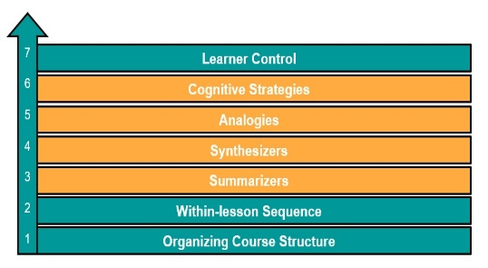 | Help learners to integrate content elements into a meaningful whole
5 | Analogies | Learning is a lot like putting information into a computer, if you can learn how to put the information into the computer correctly, it is easier to retrieve that data later. | These relate the content to learners' prior knowledge, using multiple analogies
6 | Cognitive Strategies | “Please Excuse My Dear Aunt Sally”: the order of mathematical ops: parentheses, exponents, multiplication, division, addition, and subtraction | Including things like pictures, diagrams, mnemonics.
7 | Learner Control | The learners can choose which aspect of the initial lesson to study in next week’s class | Learners are encouraged to exercise control over both content and instructional strategy

