Lab #1
TU850/1 - Creative Coding

Your working lab has to be shown to (and signed off by) the lab demonstrator between 12 noon and 2pm on Monday 10th of February, in CQ-233/CQ-236.
REMINDER:
To draw the following image:
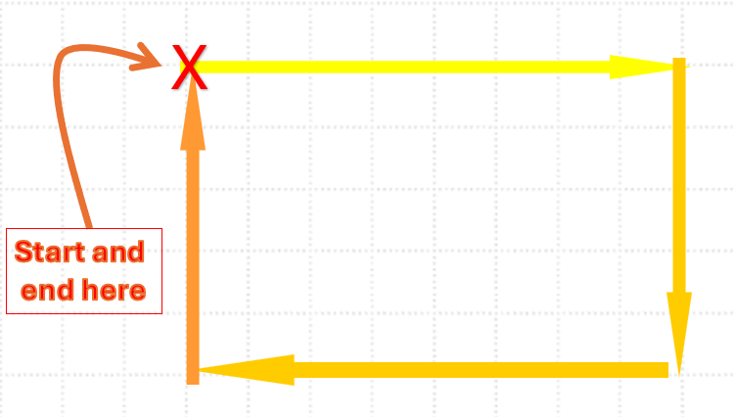
We can use this code:

Python with Turtle
# PROGRAM DrawRectangle
import turtle

# Set up the turtle
t = turtle.Turtle()
t.speed(3)
t.pensize(3)
t.color("gold") # Set the colour to gold

# Draw a rectangle
t.forward(162) # Move forward by 162 units
t.right(90) # Turn right by 90 degrees
t.forward(100) # Move forward by 100 units
t.right(90) # Turn right by 90 degrees
t.forward(162) # Move forward by 162 units
t.right(90) # Turn right by 90 degrees
t.forward(100) # Move forward by 100 units
t.right(90) # Turn right by 90 degrees

# Close the window when clicked
turtle.done()

#END.

QUESTION 1
Instructions:
If ChatGPT is working (or any other LLM of your choice), please put the following prompt into it, and see what comes out.
Can you please write me a program in Python using turtle to generate three overlapping random shapes and fill them in in three different colours. Can you please make sure that all three shapes are at least partially visible, and that all three shapes overlap at least one other shape?
Submission:
Do a screengrab of the resultant image, and paste it onto your Template document:

QUESTION 2
Instructions:
You are required to draw the following shape in Python using turtle:
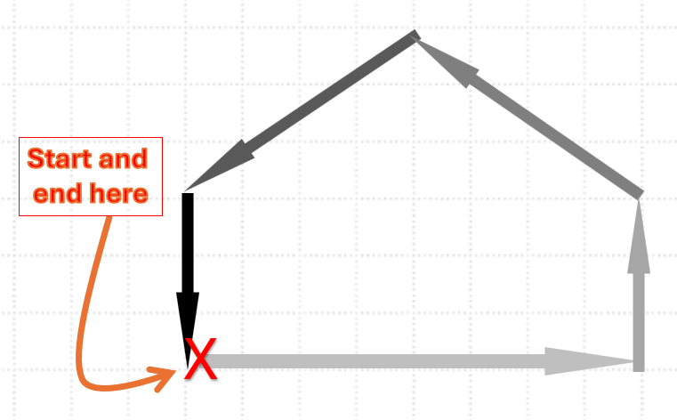
With the following dimensions:
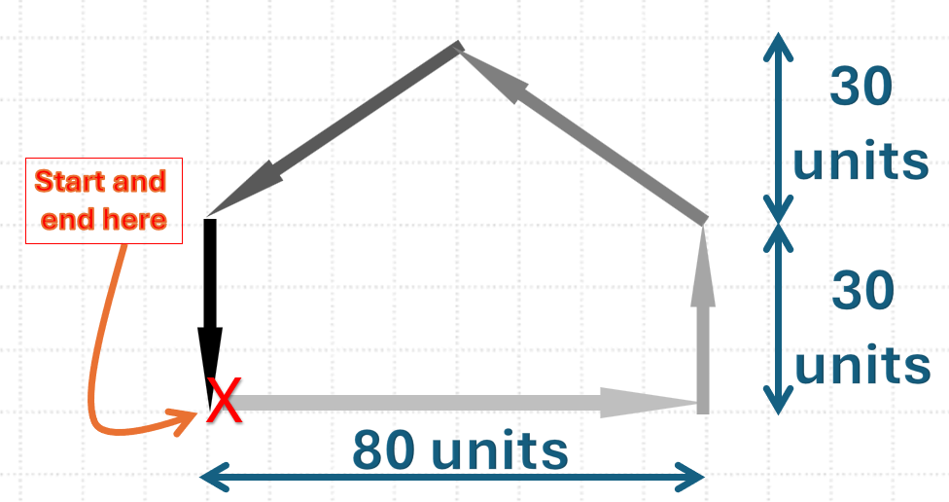

Rules:
- The shape must match the above shape, you can’t have any additional lines, and the lengths must be correct.
- You can search the web for this code on the Web if you like.
- You can use ChatGPT if you want.
- You cannot use any of the following commands: goto, setpos or penup.

Submission:
- Please submit your code and a screengrab of the specified shape.
- If you calculate the angles using Trigonometry, please include a sentence explaining the angles you have worked out in your Template document.
- If you used ChatGPT, please copy ALL of versions the prompts you used to get the correct answer, so not just to the last prompt, but all of the prompts you used. Put these in your Template document.

Search in Brightspace for the following module: “Creative Coding CMPU1042: 2024-25” and please enroll.

e-mail me a completed solution to each of the above programs in your Template document. Send it to Damian.X.Gordon@tudublin.ie with subject heading “DT850 CC Lab #1”, and put it in Brightspace as well.

